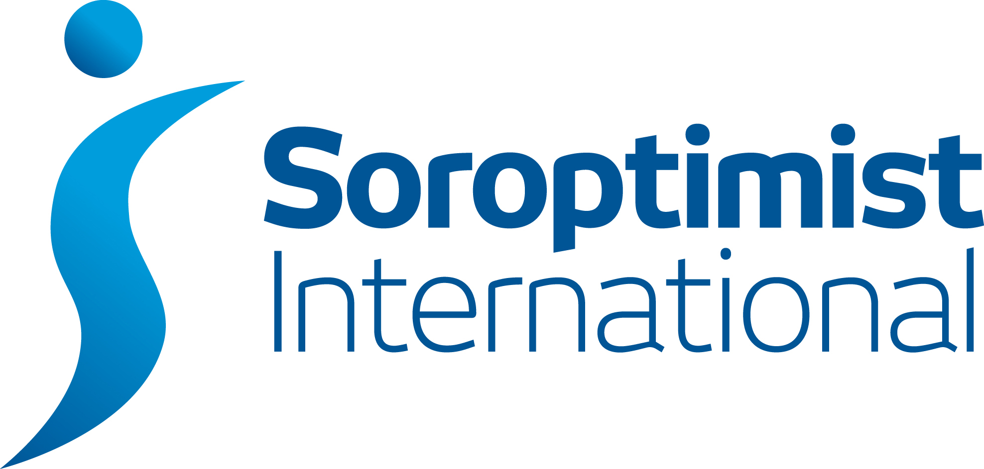

Wales South

SIWS Club PA Report to Regional Meeting

Club  SI Bridgend | Club PAO  Carys Brown
DATE OF SIWS MEETING | December 3rd 2016
Date report sent to Regional PAO & Regional Secretary
Please give a brief report on activities within your club on the following categories (boxes will expand as you key in your report). You will have 5 minutes at the Regional meeting to give a verbal report on ONE item.
Educate

Until this Term, some members of SI Bridgend continued to visit a local Primary School once a week in term time to listen to and help children with their reading. This was organised and much appreciated by the newly Headteacher Christina Bach, one of our members. It is hoped that this will carry on in another school in the not too distant future
A monetary Science award (left in Trust by the late Dorothy Worthing) is given annually to 2 pupils at a local comprehensive school who are going to pursue a career in science when they leave.
The Club supports financially, the education of a teenage girl in the Cape Verde Islands through the SI Cardiff Cape Verde project. Other members also support girls there. The Club are sent a photograph and an update on the girl’s progress every year by Gill Delgado of SI Cardiff.
Diamond Education Grant
Members continue to collect jewellery and take them to Regional meetings for recycling for this SIGBI Charity.
Members still collect other items for recycling, used ink cartridges,CDs DVDs etc.and the money is saved in the SIWSHEHT charity account for future projects.
Bras are collected for the Glamorgan Gwent Marshes club who recycle them with a given charity.
Membership Month
SI Bridgend took part if the Awareness Day for local organisations in the Bridgend area on Saturday. This was an excellent opportunity to publicise Soroptimist International as well as highlight the many local, national and international service projects that the Bridgend members are involved in.
Under the headings of ‘Educate, Empower, Enable’ a number of projects were highlighted including the International Women’s Day event, the Trafficking Conference hosted by the club, the Knitting project for Mothers for Africa, our regular Teas for the Elderly, sponsorship of young girls’ education in Cape Verde and the Water Filtration project in Pakistan.
Fun and friendship was also conveyed with photos of members visiting our friendship link club in Finland, our Christmas Tree at the town’s Christmas Tree Festival and the trip to Hay Festival.
The display generated a great deal of interest and discussion from visitors to the event and we received a number of enquiries about membership.
A lovely day and a good opportunity to spread the word about Soroptimist International.

Enable

Toilet Twinning
Earlier in the year we sent money £240 from the charity account to twin a toilet block in Pakistan. Our toilet is twinned with a school block in Tando Allahyar, Sindh Province, Pakistan, a small community in the Hyderabad area.We received the certificate telling us the exact location of our toilet block. In September Jasmine Jones from Toilet Twinning came to tell the club all about the charity, why and where the toilets are needed and how they are built and maintained. A further £20 was given to the charity.
Women’s Aid
Bridgend Women’s Aid is now run by Neath and Port Talbot Community Services and is known as Calan DVS. Members of SI Bridgend are no longer Trustees but Lily Laesser still keeps in touch with the Bridgend Office and this year, as well as delivering the usual toiletries, has collected sugar, towels and sheets. She will keep collecting from us and will tell us if there are other items we can contribute.
Barnardos
Last year’s chosen President’s charity was Barnardo’s and, in particular, supporting Barnardo’s in Bridgend and their community support for offenders’ families. Barnardo’s are working with Parc Prison on a Literacy project to support families, women and children. Our President said “Our support will help to fund workbooks for children of affected families – something that has not been done before and that, I believe, is very worthwhile.”
Members have raised money throughout the year by holding a beetle drive, a silent auction, as well as raffles and sales of craft items.
“£2200 in total was raised– £1000 has already been donated to Barnardo’s and there is more money waiting to be given when we receive a report on the progress of the project and we know what the money is needed for.
Empower
Meru Garden Project
Following a successful coffee morning and other fund raising a cheque for £585 has been sent to SIGBI for the project. Rayner gave an illustrated talk at one of our club evenings recently, to tell members who haven’t been in Regional or SIGBI conference meetings all about the project and our involvement.
Regional Project
Members continue to support the Anti Slavery Initiative by carrying the handbag labels. One member held a ‘Brunch’ recently on Anti slavery day. It was well supported by by Members of SI Bridgend and her church and it resulted in £171 being given to the Purple Teardrop fund.
Toilet Twinning has already been reported on and one member volunteered to help on the Toilet Twinning stand at the National Eisteddfod in Abergavenny on 2 days in August.
International President’s December Appeal
We raised money on International Night last December when we had supper at Marjorie Page’s home - the funds went to the International President’s Nepal Project.
Federation Project
Meru garden project supported - see above.
Work with Partners and Government
As well as Women’s Aid and Barnardos members organise and support the following:-
CONTACT THE ELDERLY - Some members continue to provide ‘Teas for the Elderly’ on Sundays once every 2 months at members’ homes. Members also provide transport and have a summer visit with tea out as well as attending Contact the Elderly teas.
KNITTING PROJECT
Members of SI Bridgend are knitting (and crocheting) squares to make baby blankets for the charity ‘Life for African Mothers’, a maternal health charity aiming to make birth safer in sub Saharan Africa,
Members were moved to take action after Angela Gorman, Chief Executive Officer and co-founder of the charity, spoke at a Club meeting. Last year’s President Bethan said, “Angela was an inspirational speaker and members were very moved by the work the charity does. This is one way we can all get involved and make a difference.”
A total of 65 baby blankets were handed over to Angela at the Club’s AGM . She will be overseeing the safe delivery and distribution of the blankets along with the large quantities of baby clothing generously donated by the people of South Wales.
Members of SI Bridgend enjoyed the project so much that several members and friends are continuing to knit and crochet. More blankets are ready along with baby cardigans and hats for new born babies.

THE PRESIDENT’S PROJECT this year our President is supporting ‘Y Bont’ a preschool facility in Bridgend which provides support for children with disabilities and their families
As well as the usual fund raising activities we had a very successful Fashion Show in October , attended by members and friends from across the region and organised by a local fashion shop, Samantha B, from Ewenny.
The evening was very successful and fun and to date over £700 profit has been raised but there is more money to come!
Tombolas
Members have run these stalls at the Lion’s Club summer fair in Cowbridge and at the English Speaking Union’s summer garden party in Fonmon Castle to raise money for our charities. Our Treasurer is always asking and collecting ‘prizes’ for the tomboys stand. After Christmas is always a fruitful time!
Local Projects
As well as those already mentioned, following our church service last year, £25 was donated to Laleston church who hosted the event and £30 to Ogmore Vale choir who sang for us.
£25 has also been given to Cancer Research.
Christmas Tree Festival
The Club has taken part in the Nolton Church Christmas tree festival each year and has provided promotional material with the tree to tell everyone about ourselves. Last year members took the opportunity to spread the message about Modern Day Slavery and Human Trafficking. Madeline Moon MP congratulated the club on their creativity and on their tenacity in continuing to create awareness of these subjects and to alert local people to be on the look out for victims here in the Bridgend area.
International Women’s Day
Members of SI Bridgend were joined by guests and visitors from other local Soroptimist Clubs for an interesting and enjoyable afternoon to celebrate International Women’s Day.
Our guest speaker Barbara Wilding, former Chief Constable of South Wales Police, amazed, inspired and informed us with tales of her experiences on a number of different Boards and the projects she has become involved with. An interesting and illuminating afternoon – and proof positive of the impact a woman can have …. even in “retirement”!
Remembrance Service
This year and last, our Presidents and other members have taken part in the Bridgend Town’s November 11th Remembrance service and have laid a wreath with the Soroptimist Logo in it at the town’s war memorial in the centre of the town.

