May 2018 Blog

As I write this blog the sun has been shining for the second May Bank Holiday weekend this year; I cannot remember the last time this happened! I am certain the weather here was much warmer than in many of our favourite holiday destinations. This was such a stark difference from the inclement weather in late February and March when many events across Yorkshire had to be cancelled!
I cannot believe that I am already half way through my Presidential Year, which I am thoroughly enjoying thanks to the very warm welcome I am receiving at all the events I am attending. If I haven’t visited your club as yet, please do send me an invitation.
So what have I been doing over the last three months?
It has been a very busy few weeks with two clubs celebrating their 90th Charter Events. Firstly, SI Sheffield’s Dinner in March and then SI Halifax’s Lunch in May. It was wonderful that Federation President Sue Biggs and her husband David came over the Pennines for both of these occasions. Both events were excellent; the clubs should be congratulated on their superb organisation, delicious food and great friendship.
In addition to the 90th Celebrations, I have also attended lunches or dinners at SI Skipton, SI Ilkley and SI Selby and the Annual General Meetings of some of our 22 clubs. It is such a privilege to attend club meetings and hear all about your inspirational programme action work you are undertaking to help transform the lives of women and girls.
I was also delighted to attend SI Selby and SI Garforth Elmet’s membership events earlier this month. I hope that they are successful in recruiting new members to our wonderful organisation.
One of the highlights of the last three months for me was International Women’s Day at Kala Sangam in Bradford where members braved the snow to get the ‘Inspirational Women: Power of a Second Chance’ event. The challenging programme was truly inspirational and really gave an insight into the lives of women who have faced violence and abuse in the past and how they have transformed their own lives and are now able to help others in similar circumstances.

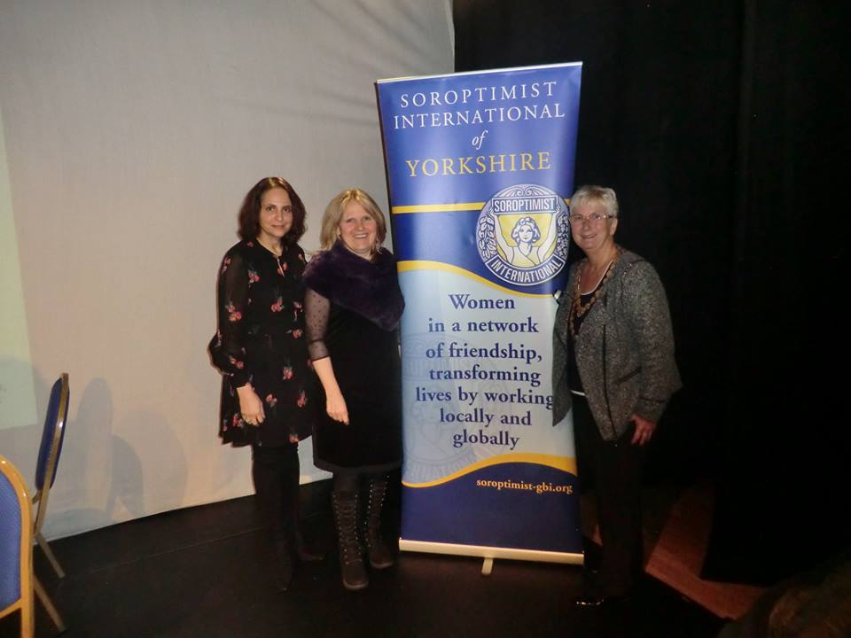 | 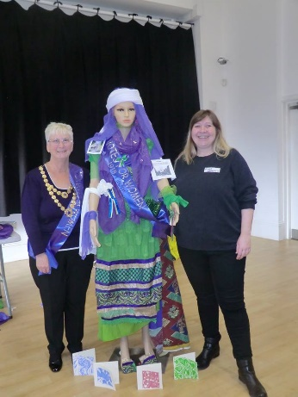 | 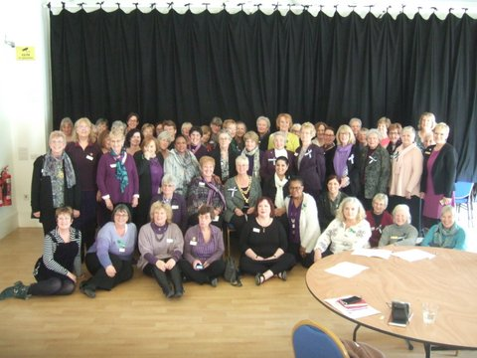

In friendship,

Chris.
Regional President

